CREATE INTERFACE

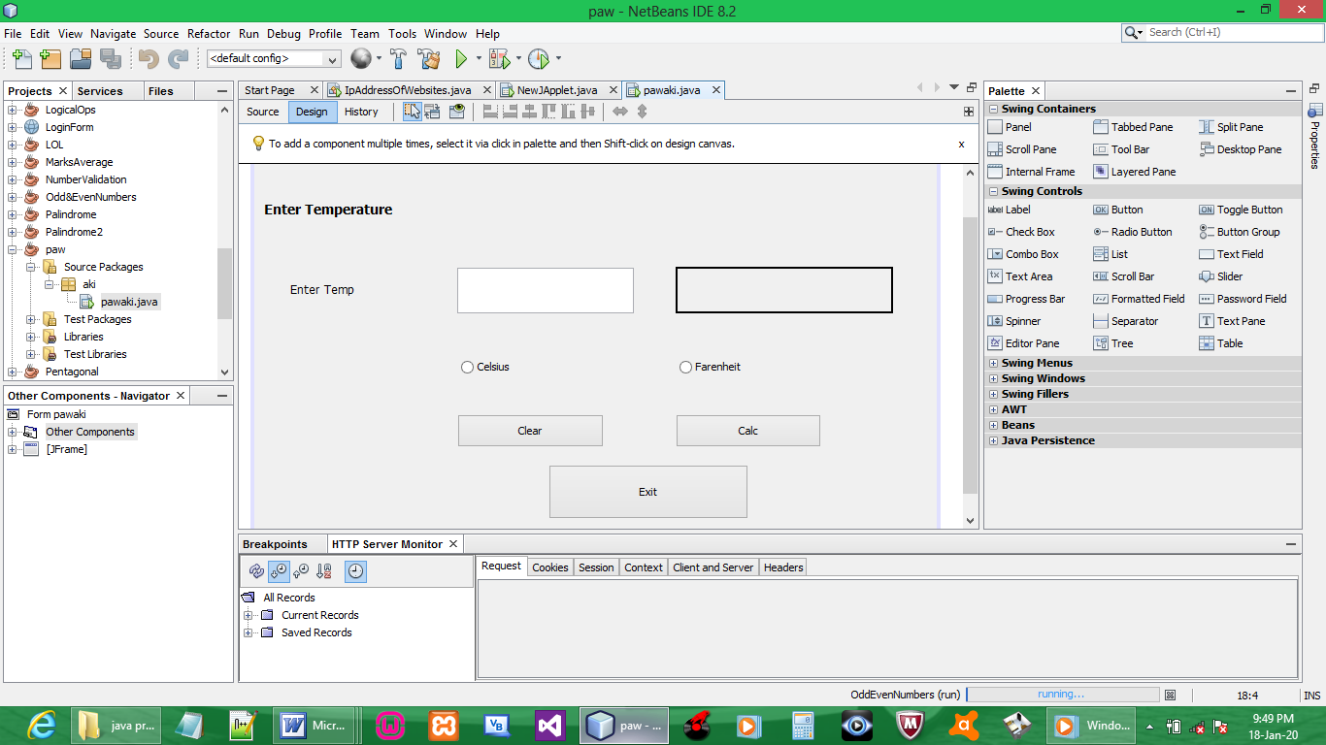

CODE:

BUTTON CLEAR

private void btnClearActionPerformed(java.awt.event.ActionEvent evt) {
txtTemp.setText("");
rdCelsius.setText("");
rdCelsius.setSelected(false);
rdFarenheit.setText("");
rdFarenheit.setSelected(false);
lblResult.setText("");
}

BUTTON EXIT

private void btnExitActionPerformed(java.awt.event.ActionEvent evt) {
System.exit(0);
}

BUTTON CALC

private void btnCalcActionPerformed(java.awt.event.ActionEvent evt) {
try{
double t = Double.parseDouble(txtTemp.getText());
double r;

if (!(rdCelsius.isSelected()) && ! (rdFarenheit.isSelected())){
lblResult.setText("Select C or F");
}

if (rdCelsius.isSelected()) {
r = ((t * 9) / 5) + 32;
String result = String.format("%.2f", r);
lblResult.setText(result);
}

if (rdFarenheit.isSelected()) {
r = ((t - 32) * 5) / 9;
String result = String.format("%.2f", r);
lblResult.setText(result);
}
}

catch (NumberFormatException e) {
lblResult.setText("Must be a number");
}
}

OUTPUT:

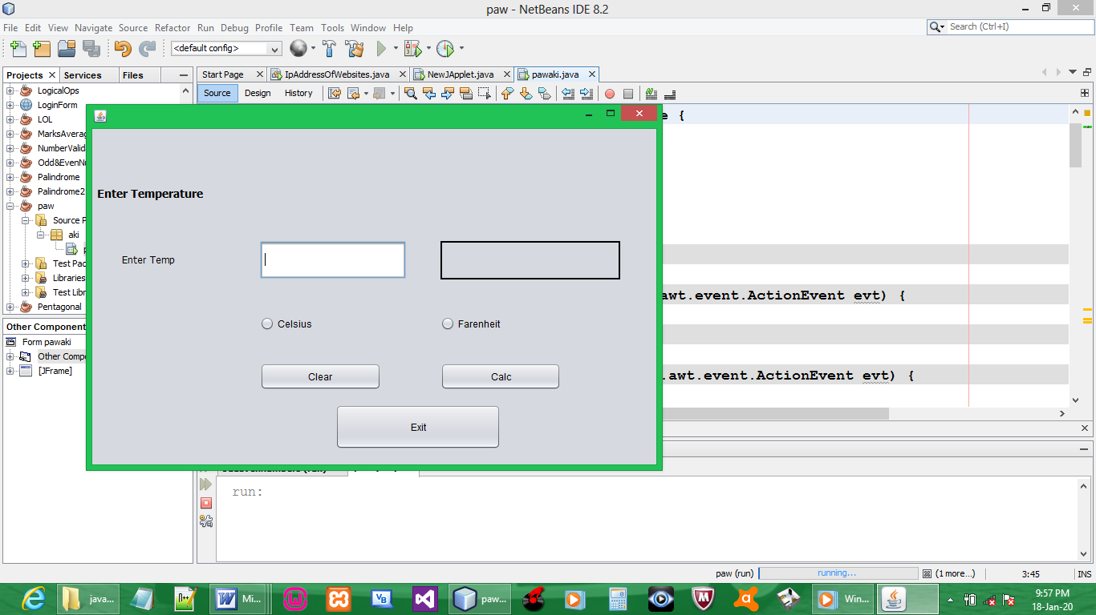

Temp to Celsius

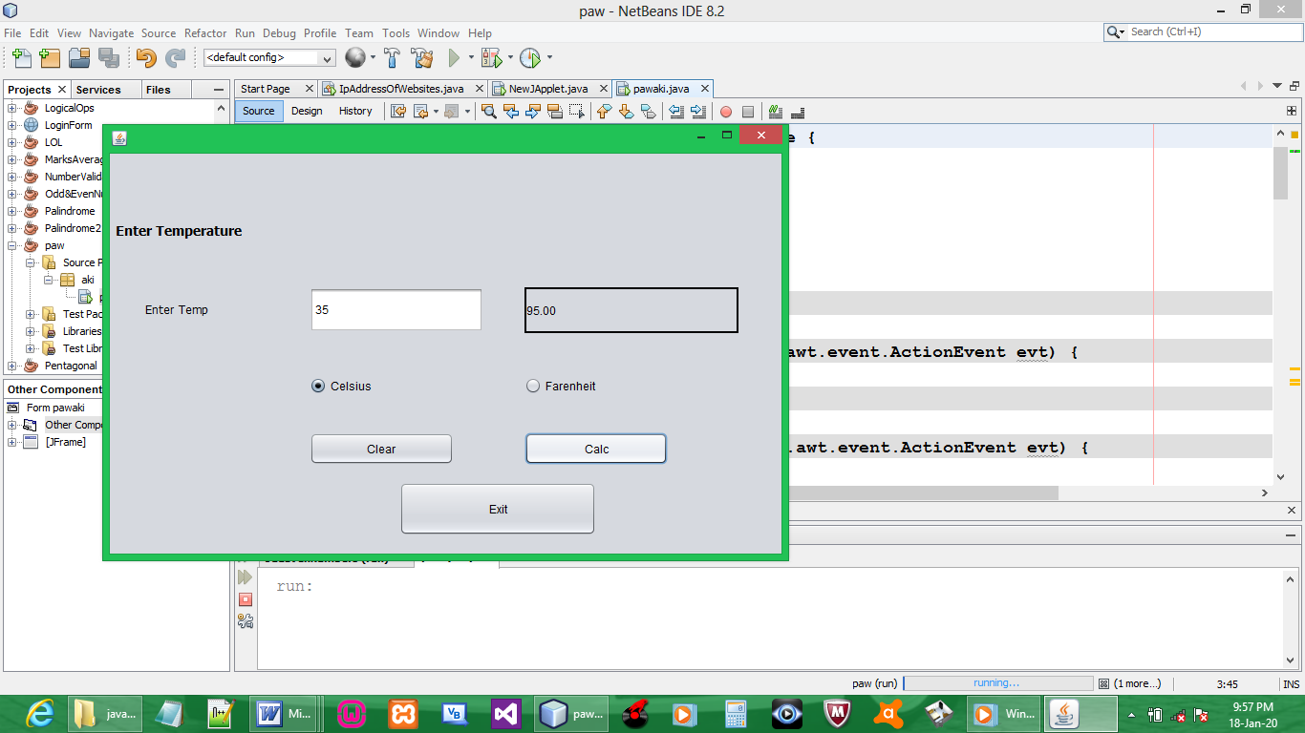

Temp to Fahrenheit

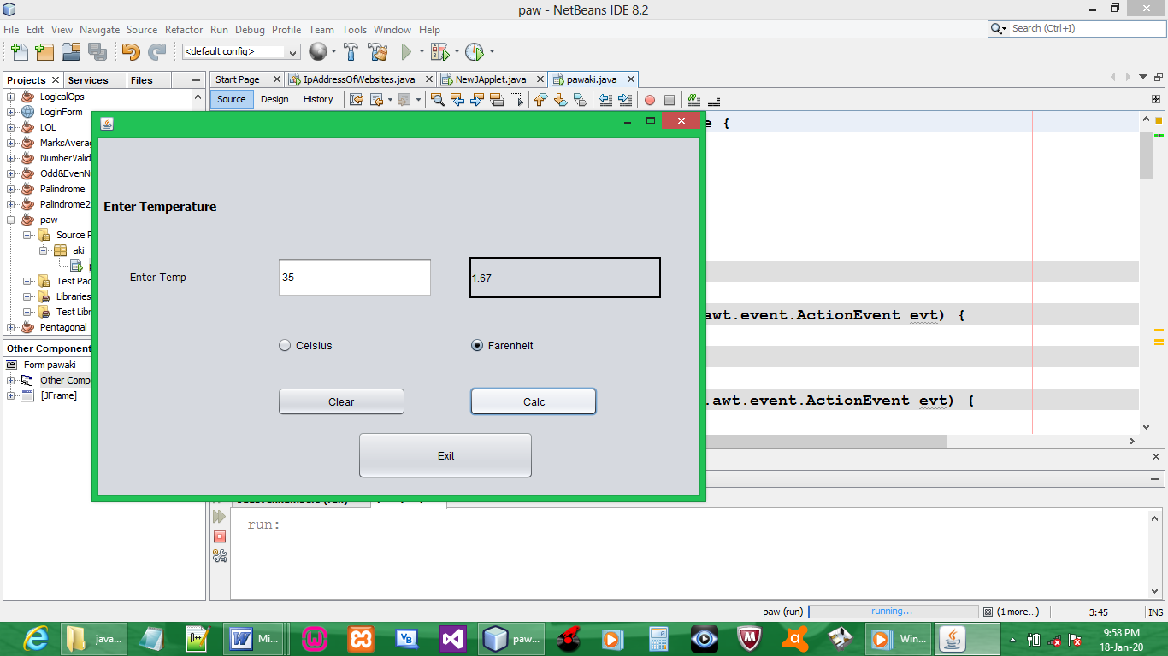

Button clear

